TWO Officer / Director Bio

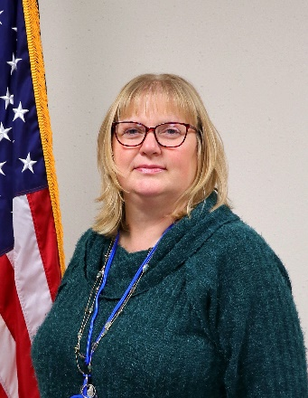
Name: Helen Davis

Brief Summary:
Helen joined the FAA in 1998 at the Mike Monroney Aeronautical Center (MMAC) as a PC Technician and has held various positions including Desktop Special Projects (Change Management) and currently Enterprise Architect. She has collaborated with numerous internal and external FAA organizations to bring about changes, both required and/or in better business efforts. Helen has been a current TWO member since November 2010 and has had the privilege of working with several current and past TWO officers and members. She has coordinated and staffed a few tables for various MMAC events, including TWO pertinent interviews with MMAC technical managers and executives. She has participated with the MMAC PMO’s Project Management Mentoring Program, as mentee and mentor, and will be graduating from the MMAC AsCEnD program.
Helen’s background includes over 30 years of IT service and business experience from both private and government organizations. She has worked as a data entry operator, PC technician, system administrator, project manager, team lead, and Technical Review Board (TRB) Intake Coordinator and meeting chair that impacts 5,000+ workstations over seven supported organizations. Helen’s experience has also included system administrator of OS/2 and Novell systems and has received A+, ITIL Foundations, and various hardware certifications. She also had the pleasure of studying PMP’s Project Management theory, FAA network architecture, and Oracle / SQL Database Administration. She mediated projects between organization leaders and management that dictate policies and clients that have to maintain operations for their DOT/FAA and external clients.
Personal Item:
Helen lives in a small town in Oklahoma with her spouse and five rescue dogs. During her younger times she helped raise three siblings, a niece and step-daughter, and also fostered many more children. Helen completed four degrees…microcomputer support, programming, management, and security and forensics. She had one of the last honors to work as a 2015 CFC Loaned Executive with the Oklahoma City United Way and a member of Toastmasters to refine her briefing / presentation skills as she provides briefings, presentations, and discussions for various projects or gives to MMAC organizations and external customers.
Helen’s hobbies include minor construction (as well as designing and building her own basic furniture), traveling, stock investing, crafting and quilting, genealogy including history research and acting as one of her family’s historians, and taking classes on new products and experiences. She has previously volunteered with the Oklahoma Red Cross Disaster Action team, including working the 1995 OKC Murrah Bombing, and her church. Her skillset includes hardware support/troubleshooting for various machines, system administration, some budgeting, and project management.
TWO Regional / National Message:
Dear TWO Team,

I am honored to serve you as your 2021-2022 TWO Vice-President and TWO MMAC Director. I look forward to the challenge in supporting and continuing to grow TWO MMAC and national organization and qualified women in the technical workforce. Additionally, I expect to bring relevant ideas for the TWO members and officers to the benefit of the TWO organization and FAA.

Respectfully,
Helen Davis
TWO MMAC Director / Acting National VP

