TWO Officer / Director Bio

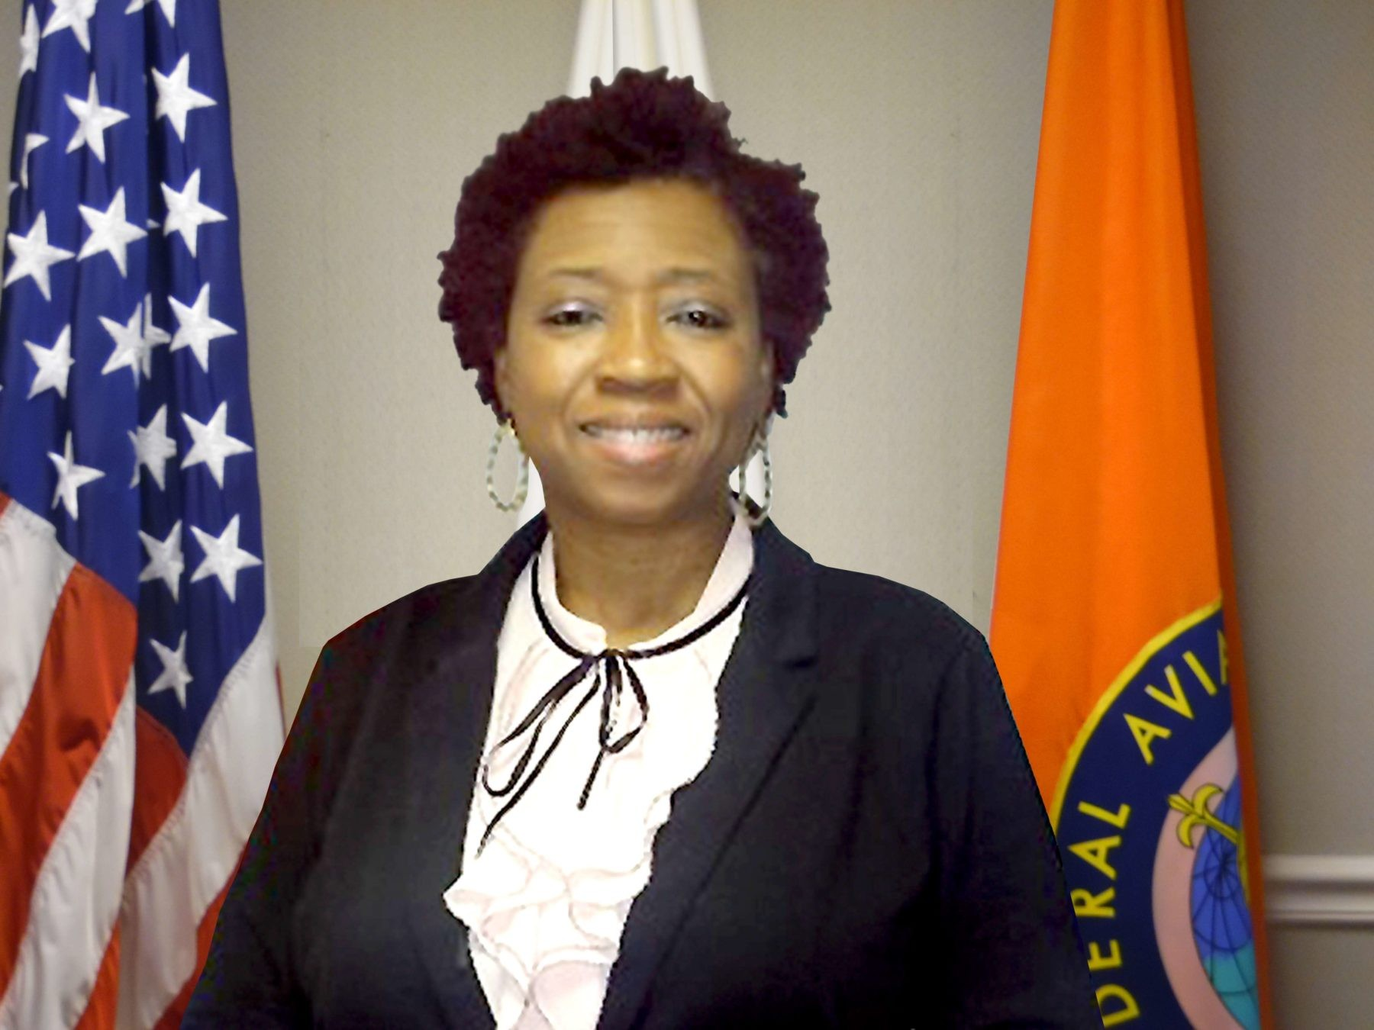
I, Bridget Y. Turner has been employed with the Federal Aviation Administration (FAA) since 1993 as an Airway Transportation System Specialists (ATSS) in Communication and Automation out of Chicago, IL and Indianapolis, IN. I am now, the Program Support Specialists (PSS) for the Washington District in Leesburg, VA where I’m responsible for over 300 employees training path to certification of NAS equipment, Environmental Occupational Safety & Health (EOSH) and managers career training.

Bridget is the National President of the Technician Women Organization (TWO), with over 300 members, whose creed is to provide support, increase awareness, promote understanding, and create a climate of advancement for technical professionals supporting aviation safety. She joined in 2012 and has served in various capacities ever since.

As a member of TWO, I was instrumental in the development, planning and execution of the TWO 2020-2021 Financial Matters Series; where financial tools were provided to help members expand their understanding of their TSP, Life Insurance and budget planning. I assisted in the execution of presentation of the 2021 Book Series; “Dare To Lead” by author Brene’ Brown.

I served as the Eastern (2017-2021) and New England (2020-2021) Region Director and Chair of Logistic and Budget for the TWO 2018 Joint Conference. I am a Founding Member of the TWO Toastmaster Club, a member on the Membership, Recruitment and Bylaws / Historian committees.

I am a member of Delta Sigma Theta Sorority, Inc. (DST), Alpha Phi Omega (APO) Service Fraternity and past member of the Illinois Association of Parliamentary (IAP). I love interior design, event planning, outdoor activities, dancing, roller skating and I am an advocate movie goer. I love being a Youth Mentor, speaking at Career Fairs/events and helping with the Aviation Career Education (ACE) Camps.

I have three wonderful children. I love God and I am blessed and highly favor. I am passionate about my family and community service.

